# Member – ASJMC

Position title: Member – Association of St John Members Cymru

Professionally Accountable to: Deputy Chief Volunteer

Directly Accountable to: Regional Chairperson - ASJMC

Location: Home based

Hours: approx. 10 hours per month

Salary: This is a volunteering post

Job details:

As a member of the Association of St John Members Cymru, you will promote and support the Association within your divisions and county, working closely alongside other members of the association and be support representation at welfare hubs for operational members at events, recruitment drives, fundraising and other functions within your divisions and counties. Attendance at meetings arranged by the Regional Chairperson is required.

Key duties and responsibilities:

* Proactively promote and support the Association within your divisions and counties to achieve its aims, goals and commitments.
* To network with other members of the Association
* Provide a single point of contact for the Association of St John Members Cymru within your division and county.
* Attend Association meetings either virtually or in person.
* Represent the ASJMC, from time to time as requested by the Regional Chairperson on relevant volunteer committees, Task and Finish Groups or Working Groups.
* Ensure the expectations, policies and procedures of the Association are upheld at all times.
* Be involved in and support functions such as Fundraising, Public Relations, Recruitment, VIP Events, Award Ceremonies and Presentations – at County/Divisional Level.
* Assist and attend at staff welfare hubs for Operational Volunteers at events, recruitment drives, fundraising or other functions.
* Recording your volunteer hours on a quarterly basis and submit to the Regional Chairperson.
* To attend meetings where required by the National President, Regional Chairperson, Deputy Chief Volunteer or NHQ staff.
* To carry out any other reasonable duties as required by the National President, Regional Chairperson, Deputy Chief Volunteer or NHQ staff.
* Ensure all uniform worn is kept in a clean and professional standard and abides to the current Uniform Policy.
* To complete Annual Mandatory Safeguarding training
* To ensure your DBS certificate is current and in date.

Structure

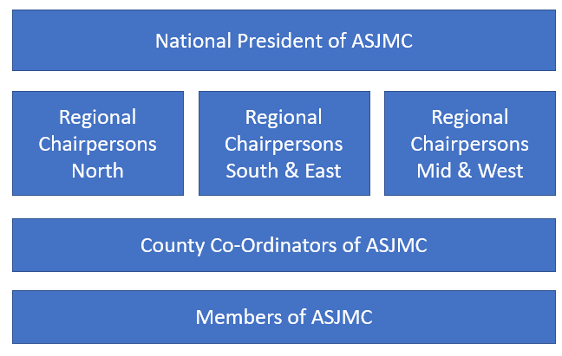

Person specification

This is a specification of the experience, skills, etc. that are required to effectively carry out the duties and responsibilities of the post (as outlined above) and forms the basis for selection.

|  |  |  |  |
| --- | --- | --- | --- |
| Requirements: | Essential: | Desirable: | Method supporting assessment: |
| Completion of Introduction to Safeguarding e-Learning | **CC:\Users\justine.thorner\AppData\Local\Microsoft\Windows\INetCache\Content.Word\Tick 2-21.png** |  | Application form |
| Hold a current BFA qualification or above | **C:\Users\justine.thorner\AppData\Local\Microsoft\Windows\INetCache\Content.Word\Tick 2-21.png** |  | Application form |
| A current (in date) DBS certificate | **C:\Users\justine.thorner\AppData\Local\Microsoft\Windows\INetCache\Content.Word\Tick 2-21.png** |  | Application form |
| Welsh Speaker |  | **C:\Users\justine.thorner\AppData\Local\Microsoft\Windows\INetCache\Content.Word\Tick 2-21.png** | Application form |
| Event Management experience |  | **C:\Users\justine.thorner\AppData\Local\Microsoft\Windows\INetCache\Content.Word\Tick 2-21.png** | Application form |
| A minimum of 5 years continued service within SJAC | **C:\Users\justine.thorner\AppData\Local\Microsoft\Windows\INetCache\Content.Word\Tick 2-21.png** |  | Application form |
|  |  |  |  |
| Skills, knowledge and abilities | | | |
| Proven experience of effective and appropriate decision making | **C:\Users\justine.thorner\AppData\Local\Microsoft\Windows\INetCache\Content.Word\Tick 2-21.png** |  | Interview |
| Experience of Managing people | **C:\Users\justine.thorner\AppData\Local\Microsoft\Windows\INetCache\Content.Word\Tick 2-21.png** |  | Interview |
| Experience of communicating with volunteers and staff | **C:\Users\justine.thorner\AppData\Local\Microsoft\Windows\INetCache\Content.Word\Tick 2-21.png** |  | Interview |
| Experience in Fundraising, PR and Recruitment | **C:\Users\justine.thorner\AppData\Local\Microsoft\Windows\INetCache\Content.Word\Tick 2-21.png** |  | Interview |
| Excellent verbal and written communication and presentation skills | **C:\Users\justine.thorner\AppData\Local\Microsoft\Windows\INetCache\Content.Word\Tick 2-21.png** |  | Interview |
| Computer literacy | **C:\Users\justine.thorner\AppData\Local\Microsoft\Windows\INetCache\Content.Word\Tick 2-21.png** |  | Interview |
| Ability to work on own initiative and part of a team | **C:\Users\justine.thorner\AppData\Local\Microsoft\Windows\INetCache\Content.Word\Tick 2-21.png** |  | Interview |
| Knowledge of Risk Assessments |  | **C:\Users\justine.thorner\AppData\Local\Microsoft\Windows\INetCache\Content.Word\Tick 2-21.png** | Interview |
| Good understanding of volunteer needs, ambitions and expectations | **C:\Users\justine.thorner\AppData\Local\Microsoft\Windows\INetCache\Content.Word\Tick 2-21.png** |  | Interview |
| Knowledge of all regulations and procedures that apply to SJAC |  | **C:\Users\justine.thorner\AppData\Local\Microsoft\Windows\INetCache\Content.Word\Tick 2-21.png** | Interview |
| Flexible to travel as required | **C:\Users\justine.thorner\AppData\Local\Microsoft\Windows\INetCache\Content.Word\Tick 2-21.png** |  | Interview |
| Willingness to commit the time to the role | **C:\Users\justine.thorner\AppData\Local\Microsoft\Windows\INetCache\Content.Word\Tick 2-21.png** |  | Interview |
| Organised and efficient | **C:\Users\justine.thorner\AppData\Local\Microsoft\Windows\INetCache\Content.Word\Tick 2-21.png** |  | Interview |
| Approachable, supportive and maintains personal integrity | **C:\Users\justine.thorner\AppData\Local\Microsoft\Windows\INetCache\Content.Word\Tick 2-21.png** |  | Interview |